Meaning and usage of “assessment” (Part I): Is it time for a new name for assessment?
November 28, 2016
Matthew B. Fuller
I’ve been working in higher education since the late 1990s and in higher education assessment since the early 2000s. For the better part of a decade, I have been researching assessment practices in American higher education, specifically cultures of assessment. So, it might come as a surprise when I say I am starting to reduce my use of the word assessment. In the interest of full disclosure, I do have some practice. In the early 2000s I had the unique challenge of working in an assessment office when a senior institutional leader forbid our office from using the words “outcomes assessment.” Red-faced and pounding on the table, he still tells me that outcomes assessment is an educational fad, doomed to die a death of attrition. That was eleven years ago and assessment is still “going strong.”
No. My reasons for not using “assessment” as much lately are not as cavalier or bullish. I’ve simply found it more accurate and accessible to talk about “evidence” or “inquiry” rather than assessment. Assessment is a term that has picked up a lot of baggage in the past decade. Many people point to the Spellings Commission on the Future of Higher Education (2005) as a watershed moment in assessment’s history. True, this commission did indeed galvanize many assessment practitioners and scholars and motivate their interests. The commission also painted a picture of the necessity of assessment in today’s modern university. That picture of necessity—which seems to have tied assessment to accountability with double knots—is the one I find problematic. It is also one I find peculiar since assessment has yet to yield the earth shattering changes any scholars and policy makers (Spellings’ Commission included) have advocated and promised it would.
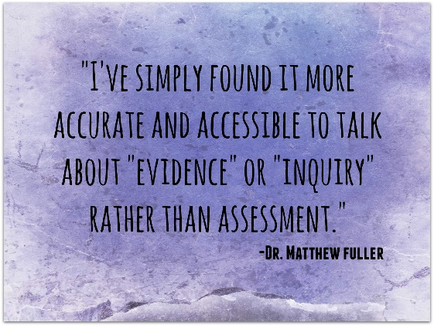
This is, in my opinion, due to the fact that when policy makers and legislators press the rhetoric of assessment, they simultaneously press the rhetoric of accountability. Now, I am not one to bemoan accountability. John Q. Public has a right to have access to data on educational performance if even a small (and ever decreasing) portion of his tax dollars are devoted to public higher education and even if he is not particularly interested in mounds of data already available. But one thing I hope Mr. Public understands is that no measure of accountability, no matter how grandiose or comprehensively administered, will ever make a student smart. Tests don’t make students smarter. Students, faculty, teachers, co-curricular partners, and advisers, engaged in partnership—in truly generative dialogue about individual students’ lives—do. In particular, if by “tests” one means any number of commercially-sold, standardized measures, these efforts in particular have grown so detached from the modern curriculum that they are hardly an effective measure of 20th Century learning, let along 21st Century learning. There are a number of notable exceptions to this claim, but in general, I have found test company representatives eager to sell their products while simultaneously telling professors and teachers not to teach to the tests. Inevitably, the conversation turns to the role of testing in learning and all involved (myself included) are challenged by whether to succumb to the pressures to teach to the test in order to ensure that some portion of our students perform well. And, let’s face it, some pretty important decisions are being made using test data, so the pressure to teach to the test is always present in any institution or school that has either gotten on the testing train or was forced onto it in the great academic pissing match that occurs over institutional or district reputation.
Sitting in the middle of all of these complex ideas is the term “assessment.” Last year we asked faculty and administrators participating in their respective versions of the Survey of Assessment Culture to describe any metaphors they heard describing their institution’s culture of assessment. For administrators bureaucratic metaphors such as machine- or production-oriented metaphors were the prevalent themes. When one considers all of the challenges and pressures administrators face in complying with accountability mandates, one need not ponder long why such answers flow freely. But for faculty, the metaphors are quite different. The overwhelming number of faculty used curse words to describe their campus’ culture of assessment. Literally more than half of all 800 faculty participating in our study said they had heard curse words in relation to assessment on their campus.
So I ask you this. How, exactly, are administrators and supportive faculty supposed to engender any sort of support for a process that elicits such virulent responses? Answers rest in two areas of thought (with many more to come through dialogue, for sure). First, we (by which I mean all educators) must stop using assessment as a proxy for accountability. Stop using terms such as “buy in” to assessment for things that very seldom give faculty or students any direct benefits, that give them nothing worth buying into. Accountability-driven assessment does just that. Learning-driven assessment however, is different. Administrators are quick to point out that accountability is a major focus of accreditation and without accreditation (i.e., presumably because faculty are refusing to provide some form or report), there can be no programs. I have known this to be for only a handful of worst case scenarios. Even in those instances the “big stick” of accountability has seldom struck its hardest. In short, even though accountability seldom results in the worst case scenarios faculty and administrators fear, the fear and threat of high-stakes penalties is enough to contort the true meaning of assessment, relegating many faculty to a position of resignation about assessment’s value. However, this “chicken little” approach does more damage than good and leads me to my second thought on how we—in particular administrators—can save assessment from what it has become.
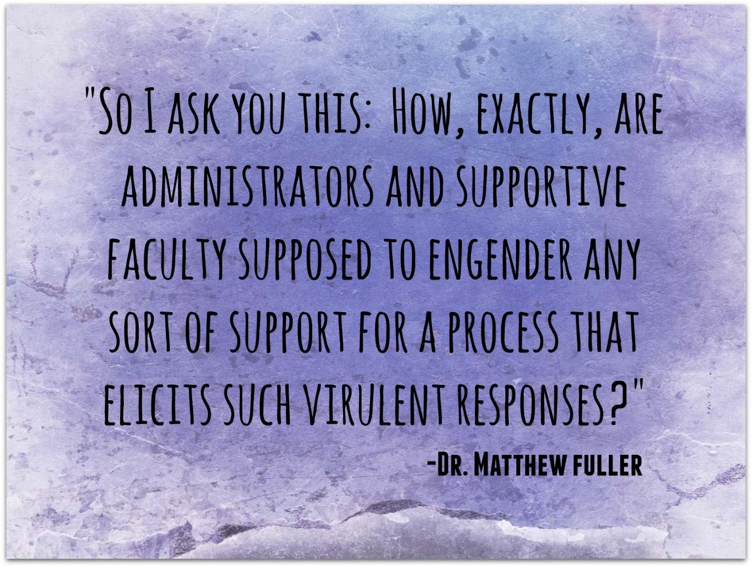
Very seldom are our institutions in such dire straits that their mere existence rests on the involvement of just a few faculty (since that is often all that assessment administrators are hoping to get to attend a meeting or provide data on time). Assessment leaders can do much to “depressurize” assessment for their colleagues and, as needed, remind accountability agents that teaching and learning, not reporting and meeting, are higher education’s first calling. Conversely, when administrators do put the accountability cat back in its bag, they should work to notify faculty of these developments. This ensures that faculty come to see administrators as “on the same page” of learning-driven assessment.
Assessment conducted with its original, uncorrupted intent is still one of the best things American higher education has going for it. But accountability efforts taken to extremes—particularly extremes of rote compliance with codes and things called “standards” that are anything but expert-derived have corrupted assessment’s original intent. Mike Gunzenhauser (2003) once wrote about the how, in the absence of a philosophy guiding educational assessment, accountability agents were able to supplant a philosophy for us, most often relying on a logic that more compliance results in better learning. Most faculty do engage in informal reviews and demonstrations of student abilities. Fitting these reviews into the jargon, models, and “education-ese” of accountability agents is as problematic for faculty as say, an accreditor or administrator describing (let along teaching) a scientific, economic, or artistic theory–which faculty do each day. The important lesson here is that neither perspective is more or less valuable to education. Both cultures, faculty and administrative, must span the cultural chasm if generative change is to take place and assessment’s current meaning is to regain some of its former glory and usefulness.
For that reason, at least until assessment turns back to its former self, I’ve begun to reduce my use of the term. It has just picked up too much baggage and no longer means the good hearted, locally-meaningful, educationally-relevant term it was when I first started my career and that I and most faculty and assessment administrators practice it under today. For now, I’ve begun favoring the notion of a culture of evidence, a culture of inquiry, evidence-based or informed decision making, or developmental assessment. I am sure my transition to these terms will be a lengthy one. But for now, I can see how a number of these terms offer the opportunity to “start over” with assessment and accomplish much of what most of us got into higher education for.
Most of my research agenda has focused on the topic of cultures of assessment and through this line of inquiry, scholars examine factors and characteristics that favor or hinder assessment and more specifically, assessment of learning. But really a number of cultures on campus influence how assessment plays out on campus and, more importantly, how learning plays out. For example a culture of inquiry, most often thought of in respect to research or pedagogy, may influence how faculty view assessment as a quest for knowledge into how well students learn. Cultures or at least patterns of collegiality on campus may influence how well administrators and faculty work together toward mutual goals. The impact of structural elements such as information technology resources or the presence of fiscal resource may have a direct relationship to change and change is influenced by assessment. For this reason, I and many others have begun to examine fundamental elements of assessment cultures and practice as we believe they hold promise for reorienting assessment toward more meaningful purposes. A more specific focus on this language or inquiry and evidence has proven effective in my dealings with faculty and administrators.
Take for instance developmental assessment. Like the adjectives “learning-driven” or “learning-centered” being “developmental” in nature enhances assessment practice in a number of important ways. Being developmental means a conscious shift back towards the improvement of learning and talents has taken place. Developmental assessment takes into account the idea that assessment is done, first and foremost, to help students learn, second, to help faculty teach at their best, and third, to design curricula in a way that supports the first two aims. Often when I hear colleagues reference assessment, they speak about elements occurring in classrooms and then a hard, poignant break in the consciousness occurs and they speak of programmatic assessment. They quickly and abruptly make the jump from classroom, highly individualized assessment to programmatic, aggregate assessment, the kind of assessment of accountability. Curricula are often the missing link and are often jumped right over in this discussion. Developmental assessment does not allow this. It seeks to couch assessment in its foundation of student learning.
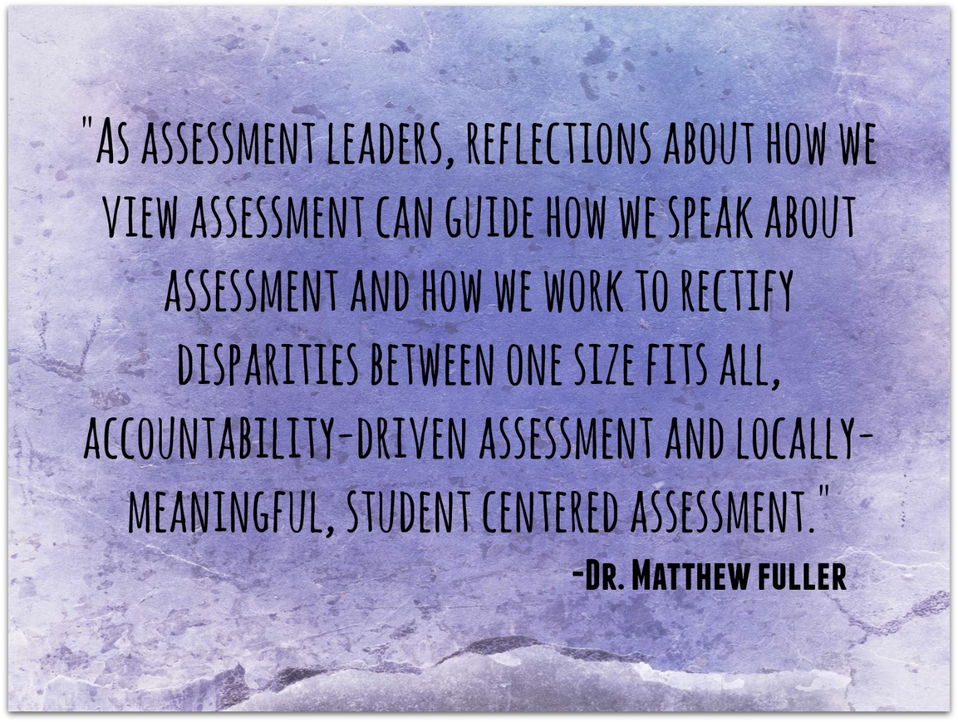
What then, is the developmental assessment process? In coming weeks, other colleagues will offer their views on this question. For now, let me simply wet your whistle by saying, development assessment is not just a process, though it certain has systematic qualities to it. For now, let me point out that developmental assessment takes on qualities that are often initially just intuited but later confirmed or measured. These qualitative aspects guide leaders to talk in different ways to faculty about assessment, to structure meetings in different ways, and design instruments and rubrics in different ways. The primary difference I see in developmental assessment and accountability-driven assessment is that assessment leaders choose to focus on learning. This fundamental refocusing of assessment on its basal elements requires us as assessment leaders to reflect upon why our roles exist in an increasingly complex and costly environment. The next few entries will help to unpack ideas about assessment versus evaluation and real-time developmental assessment that may help reorient assessment toward a more learning- and student-centered philosophy of assessment. As assessment leaders, reflections about how we view assessment can guide how we speak about assessment and how we work to rectify disparities between one size fits all, accountability-driven assessment and locally-meaningful, student centered assessment. Through dialogue with others and ourselves we can begin to refine assessment to gain a more synthesizing, collaborative, and dialogical approach to assessment for learning.
References
Gunzenhauser, M. G. (2003). High-stakes testing and the default philosophy of education. Theory into Practice, 42, 51-58.
Fuller, M. B. (2016). Faculty Survey of Assessment Culture. http://www.shsu.edu/research/survey-of-assessment-culture/faculty.html

